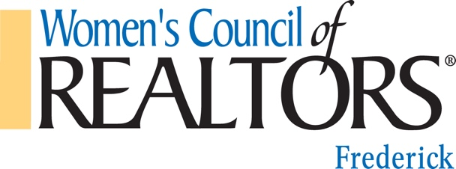
MEMBERSHIP (REALTOR®) APPLICATION

Name ____________________________________________Company Name________________________________________
Company Address________________________________________________________________________________________
City/State/Zip___________________________________________________________________________________________

Business #1Phone_(_______)_______________________Bus Fax_(_________)_____________________________
Business #2Phone_(_______)_______________________Other Fax_(________)_____________________________
Residence Address_______________________________________________________________________________________
City/State/Zip___________________________________________________________________________________________

I would like mail sent to my: Business Residence
E-mail _______________________________________________Website___________________________________________
Local Network you are joining: FREDERICK COUNTY, MARYLAND WOMEN’S COUNCIL OF REALTORS®
Board of REALTORS® where you hold Membership i.e. FCAR, GCAR, CCAR (This is mandatory for all National Membership) _______________________________________________________________________________________________________
Type of membership held: X REALTOR®
Is your REALTOR® membership: Under your name? Your company name?
What year did you become active in real estate? ___________
Your Birthday: Month______ Day________
Were you a National WCR member in the past 12 months? Yes No

2018 DUES AMOUNT OWED – (National REALTOR® Membership)
National dues: $140.00
State dues: $ 20.00
Local dues: $ 22.00
TOTAL DUES: $182.00 (1-Year Membership Dues)
Check for $__________ (Payable to “WCR”) is enclosed. Check #_______

Contact Details:
info@wcrfrederickmd.org
www.WCRfrederickmd.org

Revised: 1/2018

FOR LOCAL CHAPTER USE ONLY
Verify all REALTOR® Board information,
dues amount and payment
Information before forwarding this application.

SPONSORED BY_________________________
Application process completed by_____________
Date____________________________________
Please send completed application along with payment to:
Women’s Council of Realtors
WCR Membership – Nancy Fay
478 Prospect Blvd.
Frederick, MD 21701
Thank You!

